(Free Programs Remaining Today: 2)
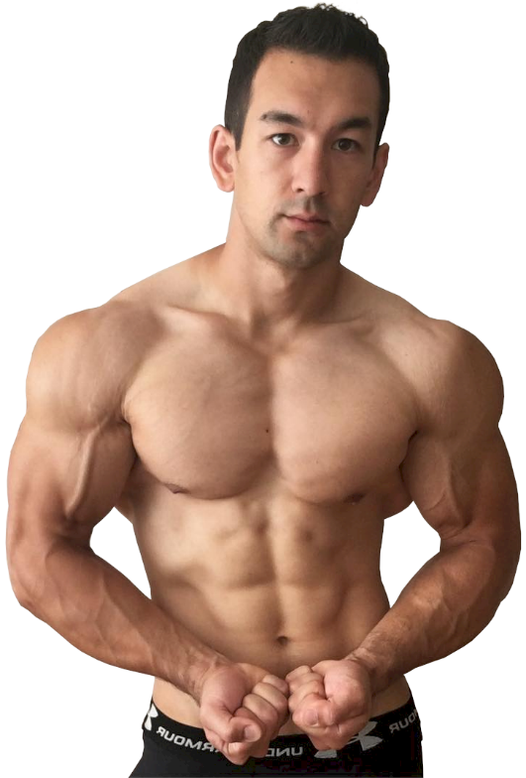
Fill Out The Form Below And I'll Personally Send You A Free Customized Fitness Plan To Help You Achieve The Head-Turning Body You're After As Efficiently As Possible.
Get started now to receive your individualized workout routine, daily calorie/macro targets and supplement recommendations…

Are you male or female?
[ ]
What is your age?
[ ]
What is your height?
[ ]
What is your current weight?
[ ]
O Pounds O Kilos
How active are you during a typical week?
O Sedentary (little to no exercise)
O Lightly Active (light exercise 1-3 days a week)
O Moderately Active (moderate exercise 3-5 days a week)
O Very Active (intense exercise 6-7 days a week)
O Extremely Active (intense daily exercise + physical job)
What is your approximate body fat percentage? (leave blank if unknown)
[ ]
Which of the following best describes your current situation?
O I have a low amount of body fat and want to put on muscle.
O I'm "skinny fat". I need to build muscle but there's still fat covering my abs.
O I have decent muscle development but still need to lose a bit of fat.
O I have high body fat and want to lean down first and foremost.
What would you consider to be your ultimate "ideal" physique?
O “Aesthetic” - I want to achieve a nice balance between both muscularity and leanness.
O “Bulky” - I want to be as big and muscular as possible and don't mind slightly higher body fat.
O “Fit” - I'm not concerned with being super lean and muscular. I just want to look fit and healthy.
Do you have at least 1 year of consistent, proper lifting under your belt?
O Yes O No
Where do you currently train?
O Gym O Home
What is the #1 thing that you feel is preventing you from making progress?
[ ]
[ ENTER YOUR FIRST NAME ] [ ENTER YOUR EMAIL ]
[SUBMIT]

Your application was successfully sent in. Please give me a day or two to go over your details and compile your custom program.
In the meantime, make sure you’re subscribed to my channel on YouTube and following me on Instagram for daily science-based muscle building and fat loss advice.
Talk soon!
